Pyspark
DataSet:

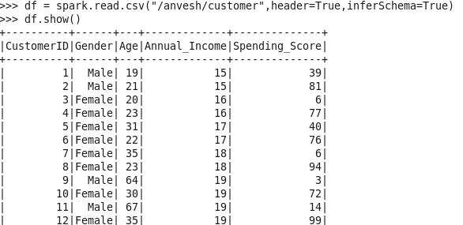

1. Customer Segmentation by Income

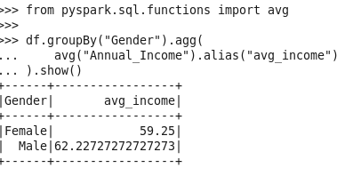

2. High Spending Customers
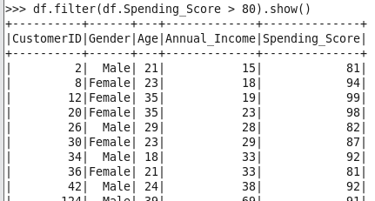

3. Age Group Analysis

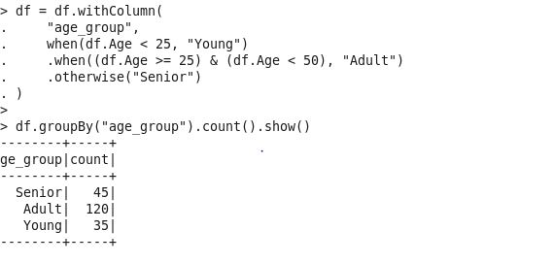

4. Top 5 Highest Income Customers

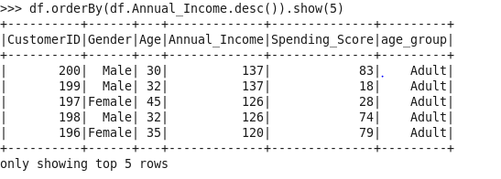

5. Spending Behavior by Gender

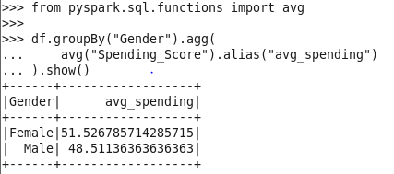

6. Correlation Analysis

7. Top Customers per Gender (Window Function)

